**HOMEWORK 1**

**Due October 1**

Hurricane Zaphod is barreling down the South Atlantic towards Florida, currently rated at Category 3. Sustained winds are in the 111-129mph range, normally distributed. It may weaken to a Category 2, or strengthen to Category 4 or even 5, we don't know.

We know that building codes in West Palm Beach mandate wind reistance up to 160 mph for commercially zoned buildings, 120 mph for residential, and 90 mph for mobile homes.

When a building fails, it fails catastrophically, sending debris in the air. Bigger commercial buildings send more debris then small ones. A commercial building can withstand 1000 debris hits before failing, a residential building 500, and a mobile home 1. West Palm Beach has 100,000 buildings, with 20% commercial, 70% residential and 10% mobile homes.

(note: I pulled numbers out of thin air -- if you find actual data, please update!).

(note2: I'm deliberately disregarding wind direction and geospatial aspects -- that's too complex to deal with for now. For purposes of this model, all buildings are within striking distance of each other)

You are a FEMA admin charged with estimating hurricane damage, as it makes direct landfall on West Palm Beach.

1. Think about model boundaries, units of analysis and time. What am I missing here? Too much detail vs. not enough? (note: I deliberately missed a few things. This is a good reflection of what you experience with real clients)

The given information only seems to give the current wind rating information, say 111-129mph, and it’s normally distributed, without the tendency of whether the wind is going to increase or decrease and at what rate. Without the information I think it’s guaranteed that everything is going to fail. Also there’s only information about how many debris they can withstand before failing, not how many debris they would send to the air when they fail, or are in the process of failing.

Also, there’re only information about how many hits different type of buildings can withstand but not how many debris different types of buildings send to the air. Like even with the information I know the failure is going to start from the 10,000 mobile homes, but how can the failure of mobile homes affect other commercial buildings?

I feel that first of all, mobile homes are going to fail first at current rate, since even the LB of the category 3 sustained winds are higher than mobile home’s resistance. And there’re 10% of buildings which are mobile homes, which are in total 100,000*10%=10,000 mobile homes.

1. Build a stocks-and-flows diagram for a direct hurricane hit -- think about hurricane approach, eye-wall, eye, and dissipation/departure

1. Write out equations that connect stocks, flows and variables

(2) and (3) please check the picture below:

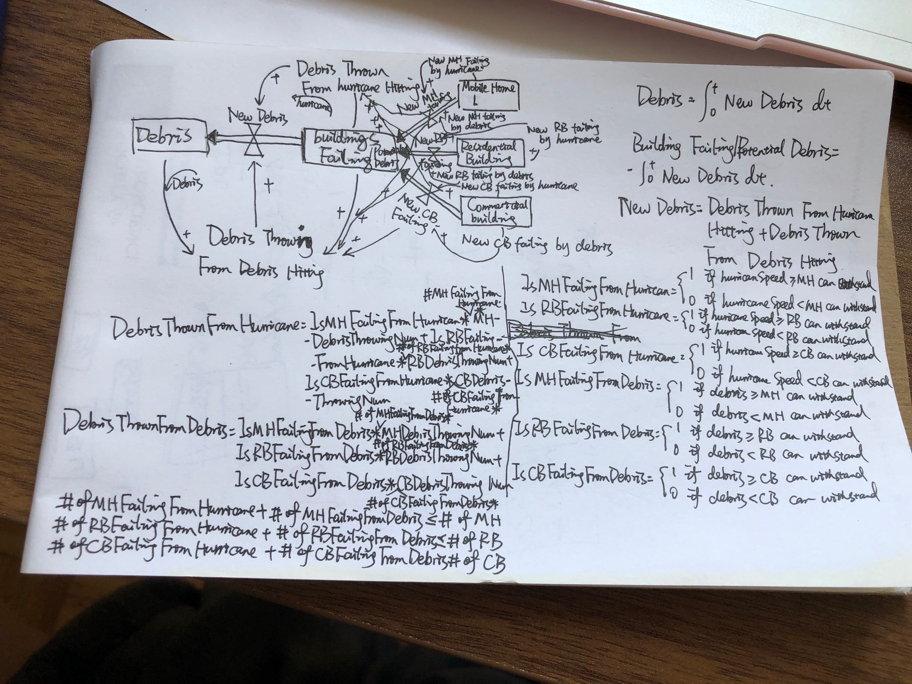

This is the 4th draft. I feel I just keep complicating it along the way

1. Using MicroSD, VennSim, InsightMaker( online&free&easy to use), NetLogo or any other tool of your choice, try to build this model and estimate hurricane damage based on speed at landfall.

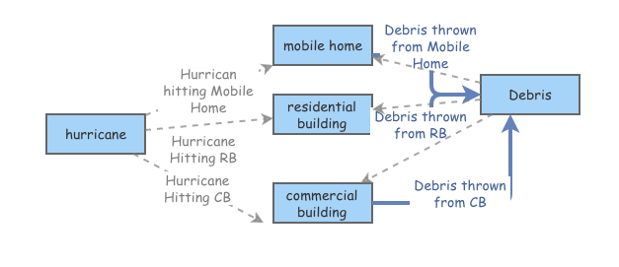

(Hints:

Use a model to generate the hurricane speed at a certain time

Control variable to manipulate the mean of the speed

Figure out the point of “no return” for this model (aka blowing everything up)

Make up the debris throwing rate-different for different type of building but have to make sense as well, also remember that in the process of building failing they throw debris as well)

1. Run some experiments with this model -- enhance the building codes, get rid of trailer parks, etc. Use a good experimental design technique. Describe your reasoning for experimental design

At current situation, the failing will start from Mobile Homes since even the LB of the category 3 sustained winds are higher than mobile home’s resistance. And there’re 10% of buildings which are mobile homes, which are in total 100,000*10%=10,000 mobile homes. Even if the hurricane only destroyed one mobile home from beginning, if the failed mobile home throws one debris, all mobile homes are doomed to fail. After 500 mobile homes failed, residential buildings are starting to fail, throwing more debris in the air, and then commercial buildings are going to fail, throwing even more debris in the air. Eventually everything is going to fail.

Get rid of trailer parks is a good idea for the model designing, since the disaster will start from mobile homes and they have very little resistance towards hurricane. I would say also enhance the building codes-aka raising the wind resistance of residential building and commercial building, in which case, it’s very rare for hurricane to destroy residential building, and even if one or two residential buildings failed, as long as they don’t throw many debris into the air the hurricane won’t be able to do much damage.

1. Bonus question: Mar-a-Lago is a sturdy commercial building. What is the probability that Hurricane Zaphod destroys it?

#I assume that when Mobile Home fails it throws 0.5 debris into the air

#when Residential Building fails it throws 200 debris into the air

#when Commercial Building fails it throws 500 debris into the air

According to my current assumption, the 10000 mobile homes are all going to be destroyed and throwing 5000 in total debris into the air, then all the residential buildings are going to be destroyed and throwing 200*70000=14,000,000 debris into the air and all the commercial buildings are going to be destroyed in which case the probability that Mar-a-Lago being destroyed is 1

However, if you ask the probability of Mar-a-Largo being destroyed by the hurricane at its

landfall, the probability is P(hurricaneSpeed>160) when the hurricane speed has a normal

distribution of mean=120 and standard deviation=3, which is around

7.40641277190706e-41, pretty close to 0

**Grading: Valiant effort.**

Please attempt EVERY question. If you get stuck, talk to folks on Slack or talk to me. If you get REALLY REALLY stuck, describe in detail WHY you're stuck.

Legitimate reasons for stuckness:

#1 problem is badly specified -- this is given. Redefine the problem as you see fit, describe your reasoning and sally forth

#2 model does not converge and I can't make it converge

#3 Max, you're full of it. I agree, I'm full of it. ;-)